**Name: Jesnamol Thomas**

**Roll No: 06**

**Batch: B**

**Date: 09/05/22**

**NETWORKING & SYSTEM ADMINISTRATION LAB**

**Experiment No.: 9**

**Aim**

To find sum of first 10 natural number

**Procedure**

#/bin/bash

sum=0

for (( i=0; i<=10; i++))

do

sum=$((sum + i))

done

echo "sum of first 10 natural number is:" $sum

**Output**



**Aim**

To check a number is palindrome or not.

**Procedure**

#/bin/bash

echo "enter the number"

read num

rev=0

n=$num

while [ $num -gt 0 ]

do

a=`expr $num % 10`

rev=`expr $rev \* 10 + $a`

num=`expr $num / 10`

done

echo $rev

if [ $rev -eq $n ]

then

echo "Number is palindrome"

else

echo "Number is not palindrome"

fi

**output**

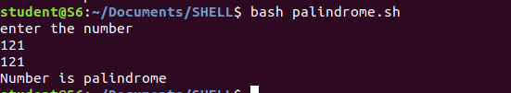

**Aim**

To find factorial a number.

**Procedure**

#/bin/bash

echo "enter a number"

read num

fact=1

while [ $num -gt 1 ]

do

fact=$((fact * num))

num=$((num - 1))

done

echo "factorial is :" $fact

**output**

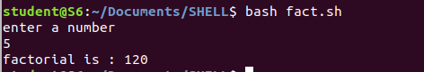

**Aim**

To find product, sum and average of 4 numbers.

**Procedure**

#/bin/bash

echo "enter the 4 numbers"

read n1 n2 n3 n4

sum=$(echo "$n1 + $n2 + $n3 + $n4" | bc -l)

average=$(echo "$sum /4" | bc -l)

product=$(echo "$n1 * $n2 * $n3 * $n4" | bc -l)

echo "sum = $sum"

echo "Average = $average"

echo "Product = $product"

**output**

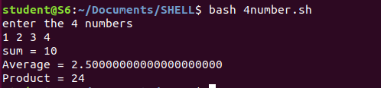

**Aim**

To check whether a year is leap year or not.

**Procedure**

#/bin/bash

echo  "Enter year (YYYY): "

read y

a='expr $y%4'

b='expr $y%100'

c='expr $y%400'

if [ $a -eq 0 -a $b -ne 0 -o $c -eq 0 ]

then

echo "$y is leap year"

else

echo "$y is not a leap year"

fi

**output**

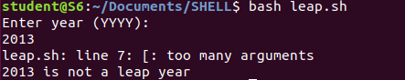

**Aim**

To check a number is gerater ,less or equal to another number.

**Procedure**

#/bin/bash

echo "enter the first number"

read n1

echo "enter the second number"

read n2

if [ $n1 -gt $n2 ]

then

echo $n1 "is greater than" $n2

elif [ $n1 -lt $n2 ]

then

echo $n1 "is less than" $n2

else

echo $n1 "is equal to" $n2

fi

**output**

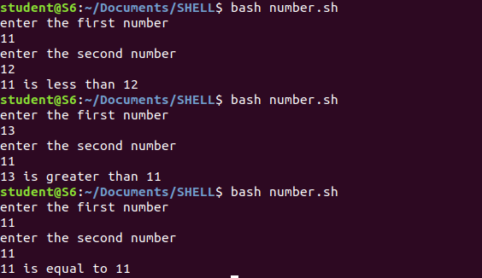

**Aim**

To print date and calender.

**Procedure**

#/bin/bash

echo "Today is $(date)"

echo ""

echo "calender"

cal

**output**

